A1015 (male)-A 1016 (female)-Indo-Timor-Ancestral Figurines-Buffalo Bone and Hair-Early 20th c

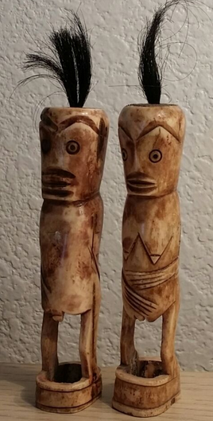 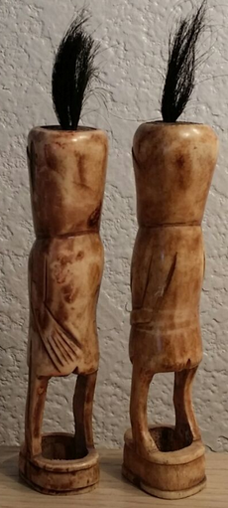 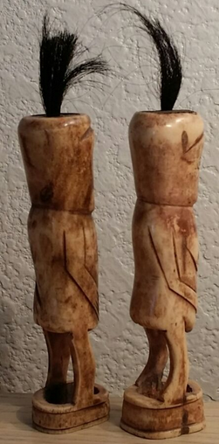

Figs. 1-3- Indo-Timor-Ancestral Figurines-Buffalo Bone and Hair-Early 20th

Case no.: 16

Formal Label: Indo-Timor-Ancestral Figurines-Buffalo Bone and Hair-Early 20th

Accession Numbers: A1015 (male)-A 1016 (female)

Display Description:

This pair of hand-carved buffalo bone fertility figures are part of Tetum shamanic paraphernalia from the Tetum people of Timor, Indonesia (previously Timor-Leste or East Timor) who numbered more than 300,000 in 2000. These figures were carved in the early 20th century by a local village shaman or Matan Do’ok (“far-seeing-eye” in the Tetum Malayo-Polynesian language) from a village 15 km west of the city of Viqueque and south of Dilor in the heart of traditional Tetum country.

The village shaman is dedicated to maintaining a balance of male-female harmony in his area of social responsibility. These figurines represent the visible part of the ceremony he conducts with newly married couples that involves their understanding of their positive (male) and negative (female) energies both sexual and social and how to maintain a healthy balance between them.

The shaman gives the figurine of the opposite sex to each of the newly married couple as a ritual wedding reminder. To further impress the couple with their mutual responsibilities as part of a marriage alliance he impresses them with the rôle of the ancestors in overseeing their alliance. Therefore, each figurine is then implanted with the symbol of the ancestors, the water buffalo’s presence in the form of its hair: the buffalo is perceived as the power of Tetum unity and prosperity between the descendants and their ancestors. The water buffalo is also the symbol of continuing prosperity and peace in the village. The tuff of black buffalo hair on top of the head of each effigy concretely represents this protective omniscience of the ancestors.

Date or Time Horizon: Early 1900’s

Geographical Area: East Timor, village 15 km west of Viqueque and south of Dilor on the Cauhoo River in the heart of Tetum culture.

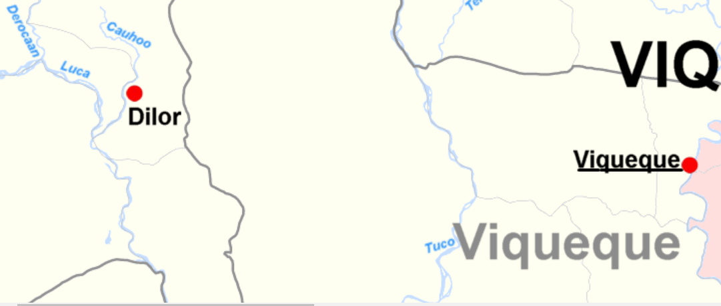

https://upload.wikimedia.org/wikipedia/commons/a/ab/Viqueque_cities_rivers.png

Map:

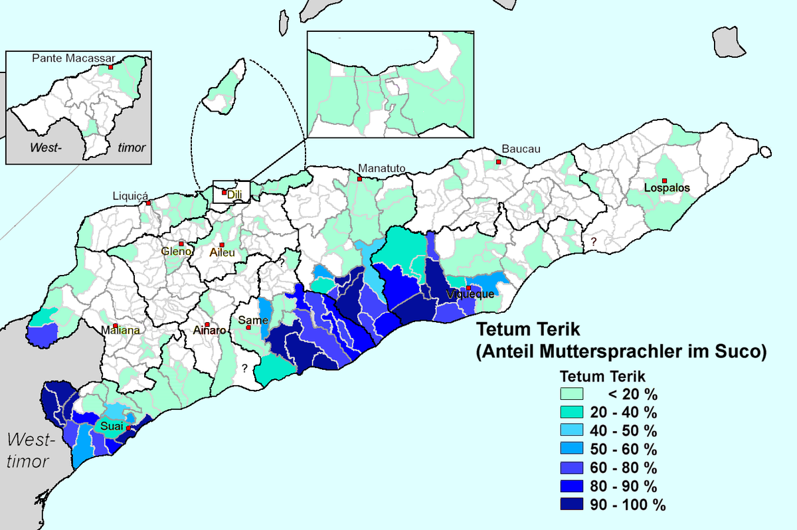

https://upload.wikimedia.org/wikipedia/commons/thumb/b/b0/Tetum_Terik.png/1200px-Tetum_Terik.png

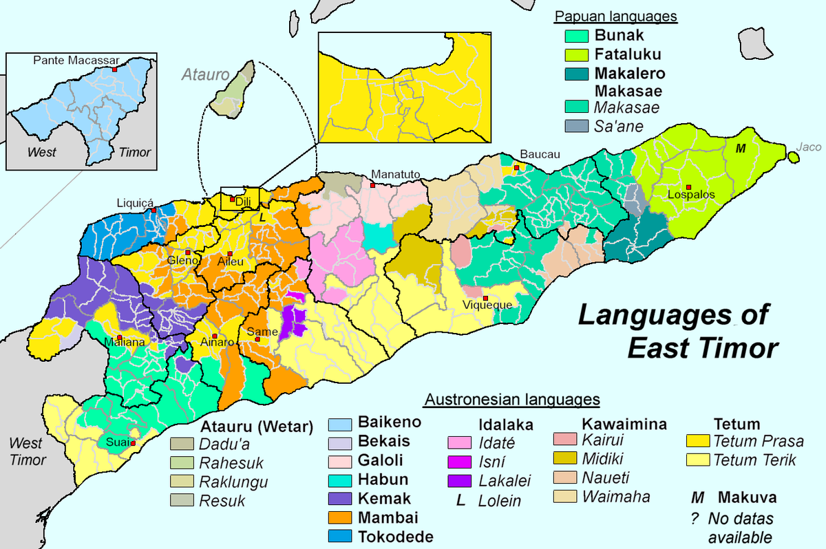

<https://upload.wikimedia.org/wikipedia/commons/thumb/d/d9/Sprachen_Osttimors-en.png/1200px-Sprachen_Osttimors-en.png>

GPS: 8° 50' 16" S, 126° 12' 45" E

Cultural Affiliation: Tetum

Medium: water buffalo bone

Dimensions: ­­­­A 1016 (female) 118.29 mm, 4.66 in; A1015 (male) 116.80 mm, 4.598 in

Weight: A1015 1.75 oz, 51 gm; A1016 1.75 oz, 51 gm

Provenance: East Timor, 1965

Condition: original

Discussion:

Continuing the theme of conjoining opposite energies in productive ways, both men and women enact distinctive and important rôles in agricultural rituals. Fields are sown by the women around a corn shrine, while men sow the seeds in the corn fields. Women represent the sacred world and men the secular. Once again the Tetum observe complex rites that are meant to conjoin these two worlds, thus ensuring a good harvest. Religious shamans, female and male, act as auditory interpreters of the omniscient ancestral spirits in meditations they both undergo in conjunction with the entire village, thus verbally communicating this ancestral power of harmony to all.

References:

Hicks, David. 2004. *Tetum Ghosts and Kin: Fertility and Gender in East Timor*, Second Edition. Longrove, IL: Waveland Press Inc.

